Functional requirements

* Inbound payments received from a corporate channel, receives pacs.008 with payments in GBP or EUR currencies sent to a file. The location of the file directory is declared in Fragmentor.msgflow FileInputNode Property input directory path. For more information, see *Fragmentor.msgFlow*.
* Validate the payment file.
* Route each payment based on currency. If IBM® ODM is integrated, further routing checks can be processed. For more information on integrating ODM with fragmentation samples, see *Decision Service Node*.
* For payments of type GBP, currency processing, mapping, and validation are done at batch level and submitted in batches to STP (straight through processing). Before STP, a batch output file of type GBP payments with the format of pacs.008 is created.
* The location of the output file directory is declared in DeFragmentor.msgflow FileOutput node Property Directory path. For more information,

see *DeFragmentor.msgFlow*.

* For payments of type EUR, currency processing, mapping, and validation are done and submitted as single payments to AML (anti money laundering) as a sanction service request, when a valid response is sent from AML sanction service response to FTM.
* Before the AML sanction service response, single payment messages (MT103) are created and put on a message queue, ready to be sent to the common system. Outbound fragments are not used for EUR payments.

# Fragmentation system interaction

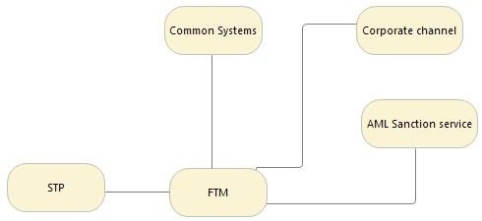

**Fragmentation system interaction with IBM ODM**

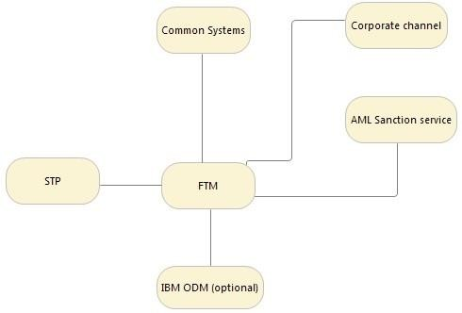

The client can submit a batch of payments for processing. The payments are processed as follows:

# Batch > Batch

This is also called bulk processing. Validation is done at the batch level and for each fragment, the payments routed and transformed and then de-fragmented.

After all defragmentation is completed, the payments message is submitted for STP.

# Batch > Singles

If the currency is Euro, each payment must be checked by sanction service before being submitted to the Euro gateway.

If IBM Operational Decision Manager (ODM) is enabled, the decision to send as batch versus singles is made by ODM based on currency.